Lab 5

Q1).

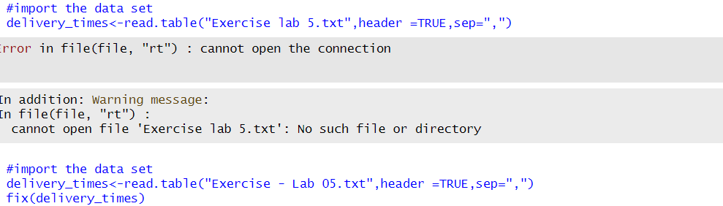

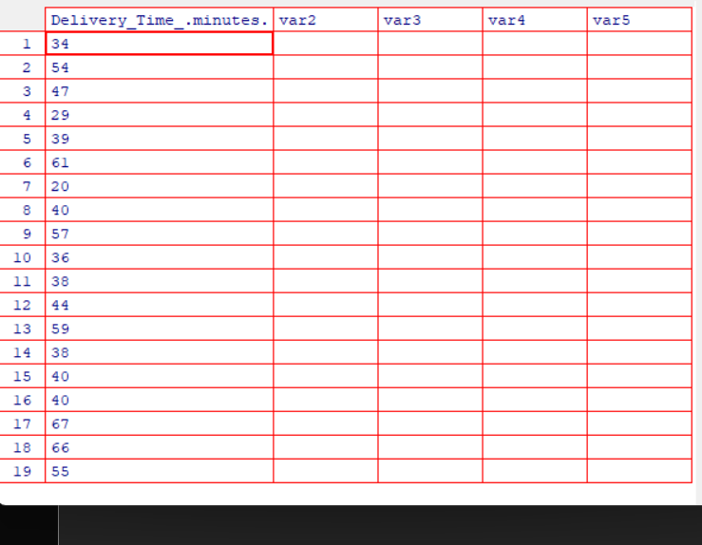



Q2).





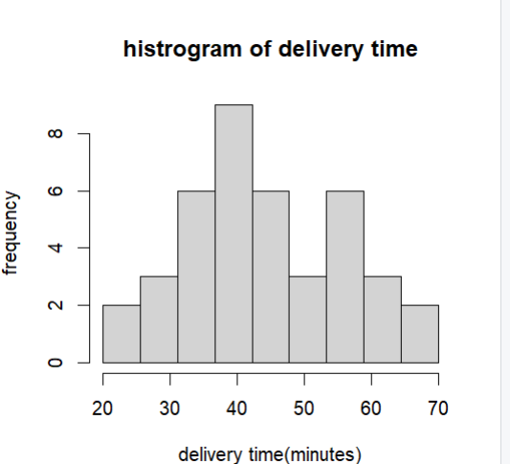

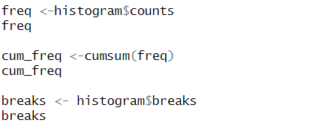

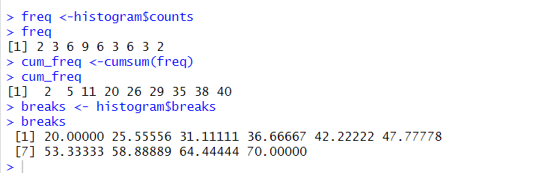



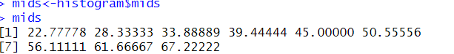

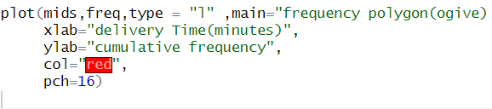

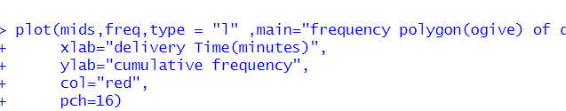

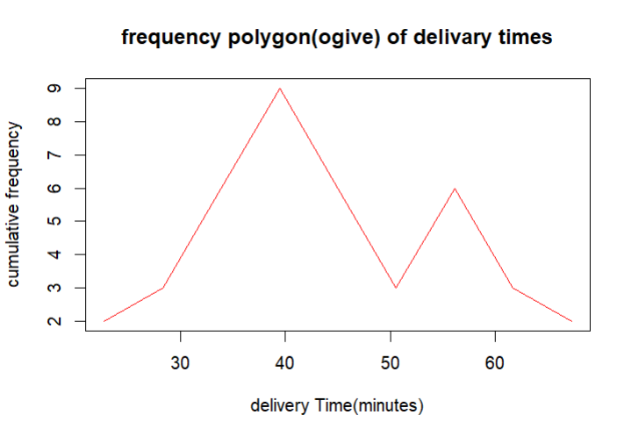

Q3).

The shape of the histogram is **approximately symmetric and bell-shaped**, with most delivery times clustering around the middle (35–45 minutes) and fewer at the lower and higher ends.

Q4).



